Sri Lanka Institute of Information

Technology



Lab Submission

Lab sheet 08

**IT24101921**

**Jayawickrama C.R**

**Probability and Statistics| IT2120**

B.Sc. (Hons) in Information Technology

**Exercise**

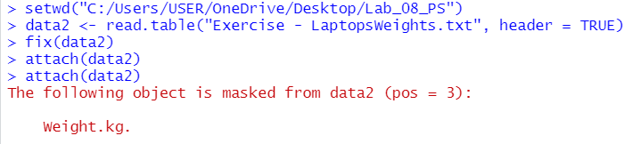

**1.**

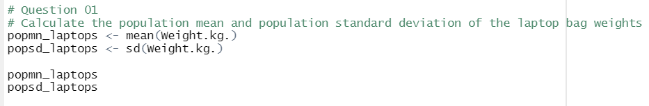

**2.**

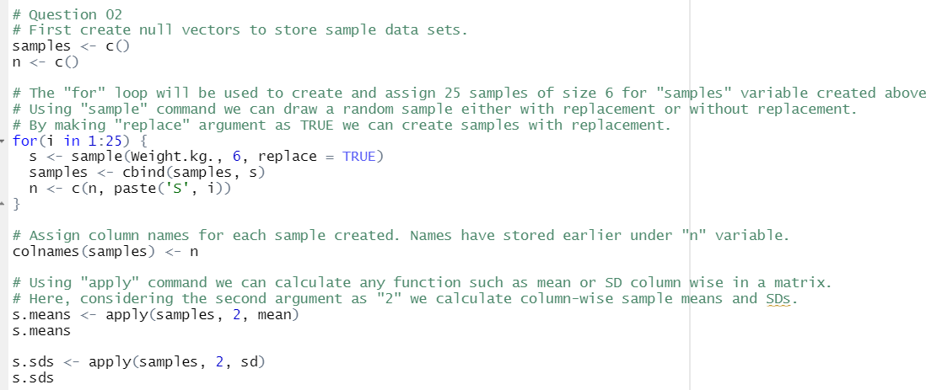

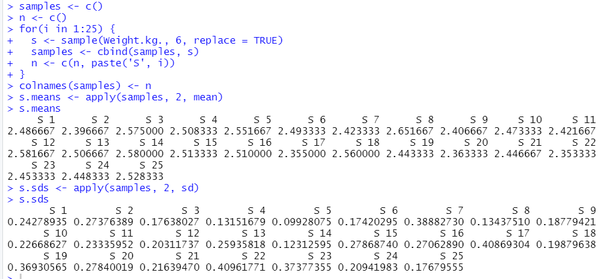

**3.**

